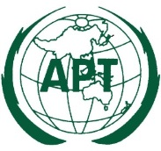 | ASIA-PACIFIC TELECOMMUNITY
 | The 5th Meeting of the APT Conference Preparatory Group for WRC-15 (APG15-5)
 | 27 July – 1 August 2015, Seoul, Republic of Korea |  | 6 May 2015

Chairman, APT Conference Preparatory Group for WRC-15

provisional agenda

- Opening

- Adoption of agenda and program

- Objectives and expected outputs

- Report of the APG15-4 meeting

- List of the documents and document allocation

- Update on structures of WRC-15 and RA-15

- Consideration of the documents assigned to the plenary

- Presentation and discussion of the views and proposals of other international/regional organizations

- Parallel WP meetings

- Presentation and discussion of consolidated reports of WP’s on the APT views and proposals

- Adoption of Preliminary APT Common Proposals for WRC-15

- Adoption of Preliminary APT Common Proposals for RA-15

- Discussion on coordination arrangements during the RA-15 and WRC-15

- Discussion of first APG meeting for WRC-19 (date and venue)

- Other matters

- Closing

____________

