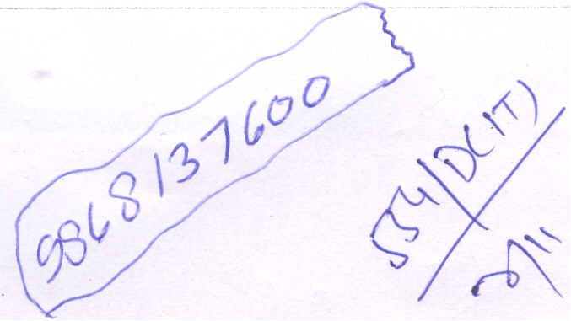
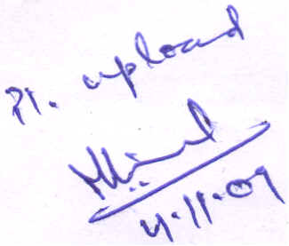

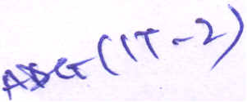
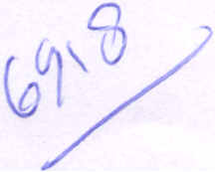
...
Government of India Ministry of Communications & I.T. Department of Telecommunications Sanchar Bhawan, 20 - Ashoka Road,
New Delhi - 110001
(DS Cell)
No. 815-66/VSAT/2009-DS
Dated : 22.09.2009
To
Commercial VSAT operators (Under NTP 99)
Sub: Amendment in Commercial CUG VSAT licence clarifying definition of
Adjusted Gross Revenue (AGR)..
In pursuance af clause No.. 12 af Schedule-"Terms & Canditians" af the Cammercial VSAT licence agreement, inter alia reserving the right to. madify at any time the terms and canditians af the LICENCE in the interest af public ar in the interest af the security af the State ar far the proper canduct af telegraphs, the LICENSOR hereby amends the fallawing terms and canditians af the Cammercial VSAT licence with immediate effect :
(a) In SI. No.. 1 (i) under heading 'Definitians and Interpretatians' after clause 35 af the Cammercial CUG VSAT licence agreement, ward 'payable' shall be substituted by wards 'actually paid'.
(b) Far SI. No.. 1 (i) under heading 'PARTICULARS' in Annexure-I af the Cammercial CUG VSAT licence agreement the fallawing shall be substituted, namely:
"Revenue from pravisianing af VSAT service as defined at SI. No.. 1 under heading 'Definitian and Interpretatians' in the licence after Clause 35",
Capy to. :
~ Directar (IT), DaT, Sanchar Bhawan, New Delhi with request to. paste the
abave amendment an the Internet site af DaT. .
A.D. (OL), Dak Bhawan, New Delhi with request to. provide Hindi translation af
the abave amendment directly to. IT cell far placing an Internet site af baT.
~~[tr4~
(R. S. Rajput)
AD (Sat-V)
Signed for and on behalf of the President of India
SJ
-
(Devendra Singh)
Director (DS-I), DoT
~9
2.
ill

